This is a bus/U-drive trip and the last hoorah for the Blazers! The trip will include 4 days of skiing and 4 nights of lodging. Accommodations will be at the Villas at Snowmass Club, a Coral Tree Residence. Villas are a short 2-minute bus ride to the base of Snowmass; the bus runs every 30 minutes. Each condominium has a fully equipped kitchen (stove, refrigerator, microwave) with all dishware and cookware provided. There are numerous amenities at the condos, just a few of which include an outdoor pool, indoor and outdoor jacuzzi and on-site restaurant. More details available at: <https://www.ski.com/snowmass-lodging/villas-at-snowmass-club>

The city of Aspen provides free shuttle service to the other three mountains (Buttermilk, Aspen, Aspen Highlands), and so traveling among them will not be an issue.

**NOTES:**

1. The price below includes a one-hour social on the day of arrival provided by the condos; dinner on two evenings, tentatively Tuesday and Thursday evenings; and a social tentatively on Wednesday evening.
2. For bus riders: You will have a boxed lunch going to Snowmass and Jimmy John’s Lunch Boxes on the way back. There will be the normal assortment of adult and non-alcoholic drinks on the bus as well, so bring your sippy cups. We will be playing games and giving away not just valuable but super-duper prizes. The bus will depart Woodman Park and Ride at 1000 on 3 February for Snowmass and depart the condos on 7 February at 1600 for the return trip. Storage for your luggage and public bathrooms in which you can change clothes will be available at the departure location on the last day. Staying at the condos allows access to the spa every day, but those choosing to not ski on the last day will continue to have access to the spa on that day also.
3. For those driving, there will be free Self-Parking.

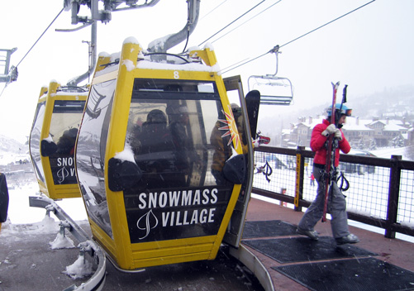

**COST:** (Lift passes are NOT included in cost)**:**

**Members:** (Must be current on dues and be a current member of the club or a returning member from one of the last previous 4 years, i.e. between 2020-21 and 2023-24. See Blazer Blast to be published soon with more details for previous members.)

* $990 if riding the bus.
* $950 for members choosing to drive. See definition of member above.

**Non-members:** (Non-members must sign a release and be a guest of a current member or be a member of the Pikes Peak Over The Hill Gang to come on this trip.) – Release found here: <https://www.ppothg.com/documents/PPOTHG_Member_Application_May2024.pdf>

* $1100 if riding the bus.
* $1060 if choosing to drive.

**Lift Ticket Options Available (Note the special on 4-day adult lift tickets):**

2-day Adult Lift Ticket Price: $286.00

2-day Senior Lift Ticket Price: $194.00

3-day Adult Lift Ticket Price: $425.00

3-day Senior Lift Ticket Price: $286.00

4-day Adult Lift Ticket Price: $425.00

4-day Senior Lift Ticket Price: $380.00

5-day Adult Lift Ticket Price: $550.00

5-day Senior Lift Ticket Price: $460.00

**Insurance is available for this trip:**

The standard Insurance plan’s cost is 7.25% of the amount of your trip. Insurance specifics are located at: <https://webservices.travelguard.com/Product/FileRetrieval.aspx?CountryCode=US&StateCode=AL&ProductCode=951501&PlanCode=NW21&FileType=PROD_PLAN_GM>

The cancel-for-any-reason-plan’s cost is 12% of the amount of your trip. Insurance specifics are located at: <https://webservices.travelguard.com/Product/FileRetrieval.aspx?CountryCode=US&StateCode=AL&ProductCode=951601&PlanCode=NW21&FileType=PROD_PLAN_GM>

NOTE: Insurance covers many things like damaged skis, injury and many other items. It is your responsibility to read the insurance policy and understand it before purchasing. Insurance must be chosen at the time you sign up for the trip. Insurance does **NOT** cover lift tickets.

**DATES:**

Initial payment of $500 (+insurance if chosen) due at sign-up (**opens 24 July 2024**). Bob will be at Putt Putt and Margaritas and will take sign ups after Putt Putt.

**Signup closes 18 September 2024**

Final balance and lift ticket payment due **13 Nov 2024**

For sign up information contact:

Robert Poulin at [robertjpoulin@outlook.com](mailto:robertjpoulin@outlook.com)

